LAB 1
Paul Mathai
15BCE0981
L3,L4

Q1

import matplotlib.pyplot as plt

from sklearn import linear_model

from sklearn.model_selection import train_test_split

from sklearn.metrics import mean_squared_error, r2_score

import pandas as pd

data = pd.read_csv("iris.csv")

x_tmp = data.temp

y_tmp = data.cnt

x = []

y = []

for i in range(len(x_tmp)):

x.append([x_tmp[i]])

y.append([y_tmp[i]])

x_train, x_test, y_train, y_test = train_test_split(x, y, test_size=0.4, random_state=1)

LinReg = linear_model.LinearRegression()

LinReg.fit(x_train, y_train)

y_pred = LinReg.predict(x_test)

print("The Linear Regression Coefficients:", LinReg.coef_)

print("The Mean Squared Error:", round(mean_squared_error(y_test, y_pred), 2))

print("The R Squared Score:", round(r2_score(y_test, y_pred), 2))

plt.scatter(x_test, y_test, color="blue")

plt.plot(x_test, y_pred, color="red", linewidth=5)

plt.xlabel("Sepal Length")

plt.ylabel("Sepal Width")

plt.show()

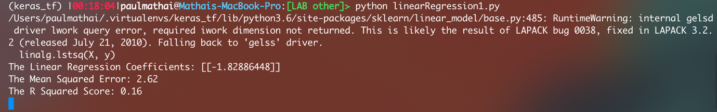

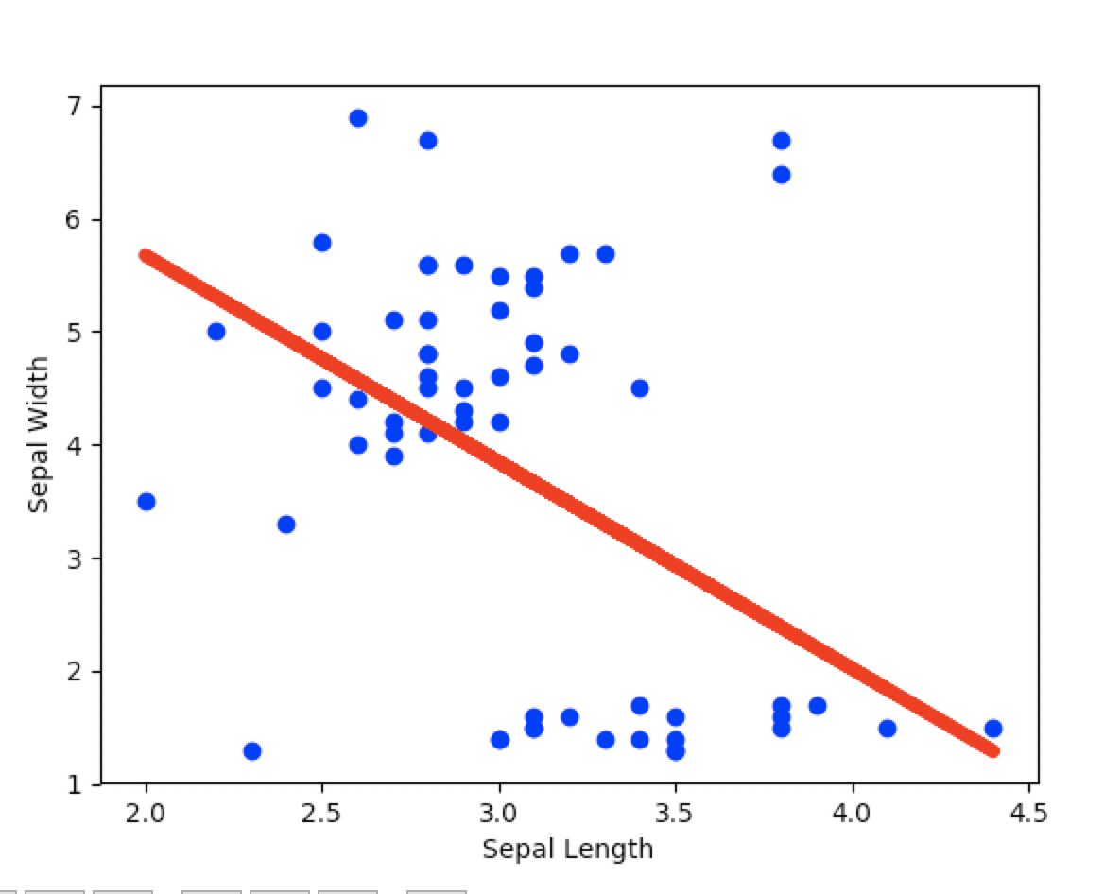

Q2
import matplotlib.pyplot as plt

from sklearn import linear_model

from sklearn.model_selection import train_test_split

from sklearn.metrics import mean_squared_error, r2_score

import pandas as pd

data = pd.read_csv("iris.csv")

x1 = data.lol

x2 = data.temp

y_tmp = data.cnt

x = []

y = []

for i in range(len(x1)):

x.append([x1[i], x2[i]])

y.append([y_tmp[i]])

x_train, x_test, y_train, y_test = train_test_split(x, y, test_size=0.4, random_state=1)

LinReg = linear_model.LinearRegression()

LinReg.fit(x_train, y_train)

y_pred = LinReg.predict(x_test)

print("The Linear Regression Coefficients:", LinReg.coef_)

print("The Mean Squared Error:", round(mean_squared_error(y_test, y_pred), 2))

print("The R Squared Score:", round(r2_score(y_test, y_pred), 2))

fig = plt.figure()

ax = fig.add_subplot(111,)

ax.scatter(x1, y, c="blue", marker="o", alpha=0.5)

ax.set_xlabel('sepal length')

#ax.set_ylabel('sepal width')

ax.set_ylabel('petal length')

plt.show()

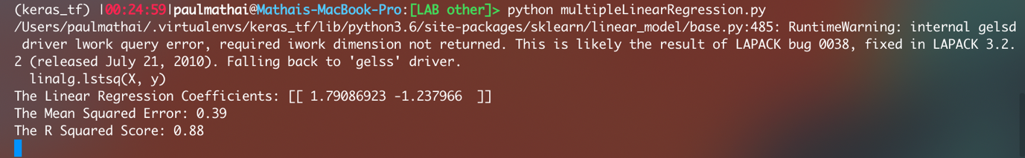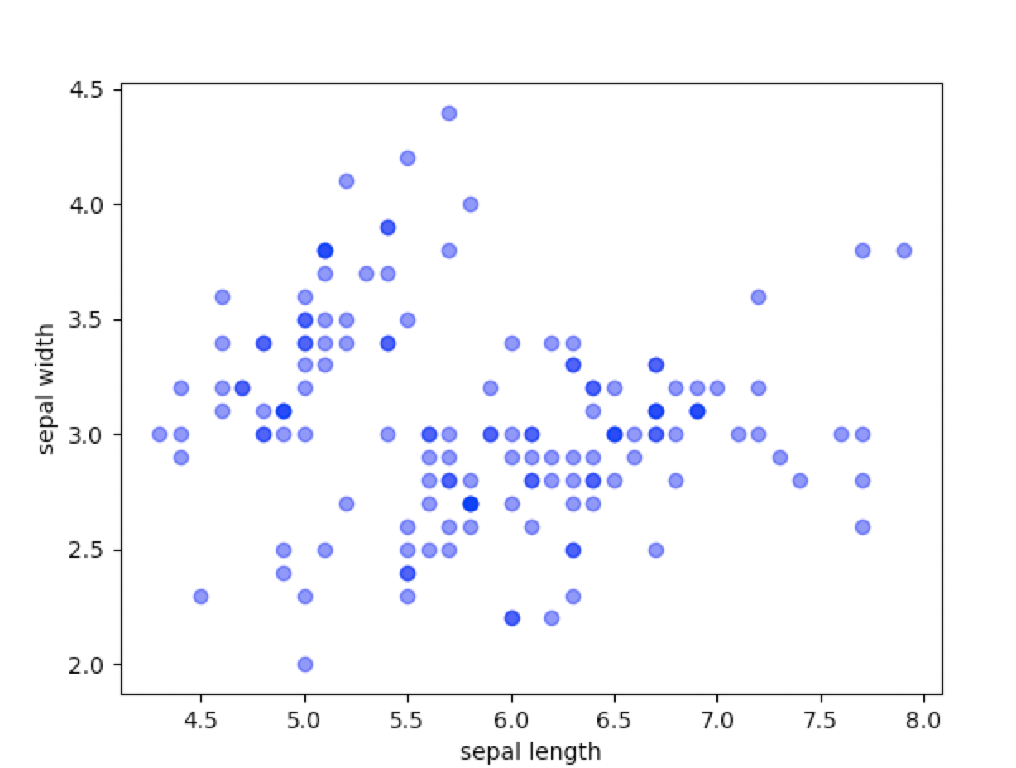
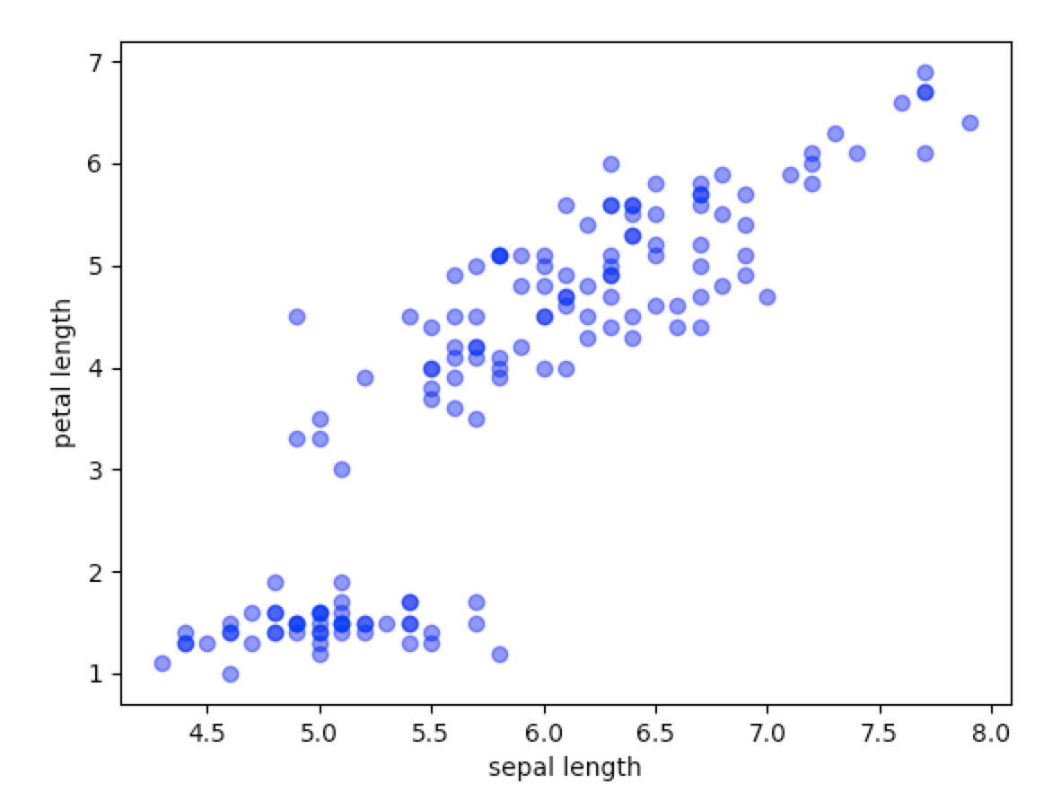

Q3
import matplotlib.pyplot as plt

import numpy as np

import seaborn as sns

from sklearn.linear_model import LogisticRegression

from sklearn.model_selection import train_test_split

from sklearn import metrics

import pandas as pd

data = pd.read_csv("iris.csv")

cols = ['lol', 'temp', 'cnt', 'end']

x = data[cols]

y = data.Irissetosa

x_train, x_test, y_train, y_test = train_test_split(x, y, test_size=0.4, random_state=0)

LogReg = LogisticRegression()

LogReg.fit(x_train, y_train)

y_pred = LogReg.predict(x_test)

confusionMatrix = metrics.confusion_matrix(y_test, y_pred)

print("The confusion matrix:\n", confusionMatrix)

print("The accuracy score:", metrics.accuracy_score(y_test, y_pred))

#print("The precision score:", metrics.precision_score(y_test, y_pred))

#print("The recall score:", metrics.recall_score(y_test, y_pred))
